Polling State

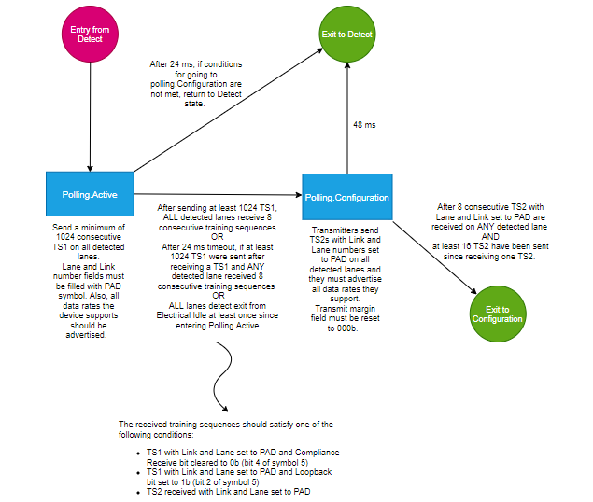

Note: two link partners may exit the Detect state at different times so TS1 exchange isn’t synchronized.

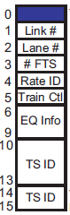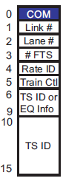

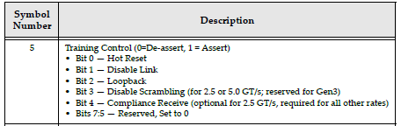

After 24 ms timeout, if: All lanes haven’t seen an exit from electrical idle since entering Polling.Active OR any detected lane received 8 consecutive TS1s with Link and lane fields set to PAD with compliance receive bit = 1 and loopback = 0 🡪 will exit to “Detect” if after 24 ms, the conditions for going to Polling.Configuration weren’t met.

Polling.Configuraion Substate:

* Stop sending TS1 and start sending TS2 still with PAD set to link and lane fields.
* Purpose for sending TS2 instead of TS1 is to advertise to link partner that this device is ready to proceed to next state → so once a device is sending and receiving TS2s then it can proceed to the next state.